

Commercial Capital, LTD Net Branch Agreement

Whereas, (Company Name), hereinafter referred to as Branch, and Nexus Financial Group, Inc/Commercial Capital, LTD, hereinafter referred to as Company, desire to enter into a mutually beneficial Net Branch agreement for Commercial Business Loans.

And whereas, Branch desires to become affiliated with Company and become a net branch of the Company in pursuing commercial Real Estate loans. This agreement will cover the entire agreement between the parties, real and implied.

This agreement lays out the responsibilities of both Branch and Company. The Company agrees to provide the following:

- Company will provide access to all their lenders via the lender list and hot list and direct access to those lenders reps and underwriters to the Branch. Branch will be FULLY responsible for processing their loans and dealing direct with underwriters and lenders (see below responsibilities of Branch). Branch can always send the deal in to corporate for corporate to process on a 50/50 split if they desire.
- Company will provide access to the net branch website that includes all forms, etc. that Company currently uses on Company Templates fully available for easy printing. In addition, that website has ALL training necessary for setting up marketing as well as all training the company has done over the years, categorized by groups. Company will provide access to the ask a question feature that allows you to ask scenario questions on which lender is right for your deal. Company president, Brian Peart, personally answers those questions once a day allowing you to leverage his 20 years of expertise to effectively shave years off of the building of your business. Marketing questions, scenario questions and business questions can all be asked via this feature. Branch will have access to the Commercial Coordinator at Headquarters as well for general support.
- Company will provide a monthly marketing and pump up conference call with Brian Peart directly and the other Net Branch Owners. This will be a powerful time of insight, knowledge, and marketing strategies and brainstorming.

- Company will provide training and assistance in setting up the marketing system as well as access to the same bi-monthly marketing that we use for our existing business. This system has proven to generate consistent lead flow and revenue flow and continues to bring in over 95% of all business closed by Brian Peart.

The above encompasses the responsibilities of the Company under this agreement.

The Branch agrees to provide/adhere to the following:

- A one-time Branch set-up fee of $10,000.00 is required up front at the signing of this agreement by the Branch. It is hereby agreed that this fee is fair and reasonable to cover all costs involved in set-up and for the proprietary lender list and access to the name, reputation, etc. of Brian Peart and Commercial Capital, ltd. There are no refunds, what so ever.

- Company is NOT responsible to answer “where to go” scenarios personally. Branch needs to utilize the “ask a question” portal that it will have full access to. Company headquarters is available for general support and marketing assistance only. Company WILL provide unrestricted access to the website for use in asking where to go scenarios. This site will allow for specific questions on finding a home for a loan and specific marketing questions of Brian Peart.
- Branch acknowledges that it is a net branch and as such, is responsible for their own expenses in underwriting, overnight charges, etc.

- Both company and Branch hereby acknowledge that neither has any ownership interest in the other entity and that Branch is only receiving a license to use the name and tools for building their business.

As further consideration under this agreement it is acknowledged that the following is also agreed upon:

Company hereby states that it has no outstanding lawsuits against it and is in good standing with all appropriate Government branches. Company agrees to hold harmless and indemnify Branch from any lawsuits or actions that arise out of any of its operations, whether retail or commercial. Branch is a separate entity for said purposes.

Branch hereby states that it has no outstanding lawsuits against it and is in good standing with all appropriate Government Branches. Branch agrees to hold harmless and indemnify Company from any lawsuits or actions that arise out of any of its operation, whether retail or commercial. Branch is a separate entity for said purposes.

In addition to this agreement, the Non-Circumvent, Non-disclosure Agreement will need to be signed by both parties protecting their contacts should this agreement be cancelled.. This agreement is part of this net branch agreement and of equal importance to this agreement.

Should Federal or State Laws make any part of this agreement null and void, it will not mean that the rest of the agreement is null and void.

It is further understood that this agreement may be modified, by mutual consent, over time. As a partnership, both parties agree to work together to find the optimum mutually beneficial arrangement and to make their best efforts to do so.

_________________________________
Brian L. Peart
President
Nexus Financial Group, Inc.
AKA “Company”

_________________________________
Signature

_________________________________
Name

_________________________________
Company Name, AKA “Branch”

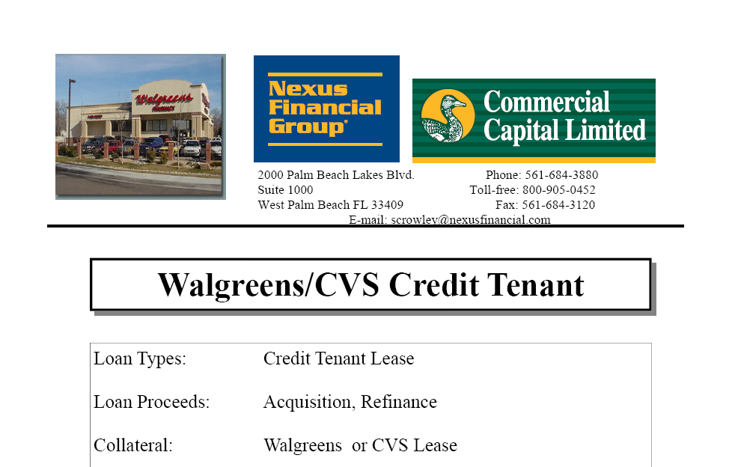

IRREVOCABLE AND NON-CANCELABLE
NON-CIRCUMVENTION AND NON-DISCLOSURE AGREEMENT

THE UNDERSIGNED PARTIES INTENDING TO BE LEGALLY BOUND DO HEREBY IRREVOCABLY AGREE:

- NOT TO CIRCUMVENT, AVOID, BYPASS, OR OBVIATE EACH OTHER DIRECTLY OR INDIRECTLY. This agreement is to confirm that each of the undersigned signatories will not deal with any entity introduced by the other signatory without knowledge and written permission of the introducing signatory. Also included within this context is any entity in which a signatory has an interest.
The parties confirm that the terms of this agreement expressly cover acts of negligence and inadvertent disclosure, which are a violation of this agreement.
- NOT TO AVOID PAYMENT OF FEES OR COMMISSIONS. IN ANY TRANSACTION WITH ANY ENTITY, corporation partnership or individual revealed by either party to the other in connection with any project, service renewal, extension, re-negotiation, contract agreement, third party assignment, communication or conversation.
Should the introducing party not be notified of any contact or should any non-signatory, their employees, agents, officers, partners, associates or consultants through direct or indirect introduction by a signatory result in successful placement of a transaction with any entity, person, company, firm, corporation, organization, the introducing signatory agrees and guarantees to pay any and all commissions and fees received by said signatory on any and all such transactions to the other signatory, unless otherwise agreed to in writing by the parties hereto.
- NOT to disclose or otherwise reveal to any third party any confidential information provided by the other, particularly that concerning lenders, sellers, borrowers, buyers names, bank information, codes, references and/or any such information advised to the other as being confidential or privileged without the written consent of the other.
It is agreed and understood that each signatory agrees to keep confidential the names, addresses, telephone numbers, tax numbers and fax numbers of any contacts introduced by the other signatory, unless prior written permission is given by the introducing signatory.
- This agreement shall be for a period of three (3) years and is irrevocable and non-cancelable. It is to be applied to any and all transactions, past, present and future, of the introducing signatories regardless of the success of the project. The signatories agree that the identities of only the parties who are introduced under this agreement are currently, and shall forever remain, the proprietary asset of the introducing signatory.
- This agreement shall be binding on the parties hereunder signed, their successors and assigns. The signatories confirm by execution of this agreement that any company, firm, corporation, partnership, organization or entity o which they are an employee, member, officer, partner, or agent, is bound by this agreement.

- All moneys due and owing from any client transaction undertaken by both parties will be irrevocably and unconditionally guaranteed to be paid without legal impediment upon request. If any ambiguity arises concerning the amount of damages, Liquidated damages will be $10,000 per violation.
- Should violation, disagreement or dispute occur between contracting parties arising out of, or connected with this agreement, which cannot be adjusted by and between the parties involved, the disputed disagreement shall be submitted to the American Arbitration Association located in Georgia and all parties agree to abide by the decision of the referees of said Association. Judgment, upon award, may be entered in any court having jurisdiction thereof.
- In the event of any conflict between the terms of this Agreement and any Loan Authorization Agreement, the terms of the Loan Authorization Agreement shall prevail.
In the event that either of the parties resorts to legal action against the other, the prevailing party shall be entitled to reimbursement from the other party for all reasonable attorney fees and other costs incurred in such action.
This agreement shall be construed and enforced in accordance with the applicable laws and regulations of the State of Georgia and of the United States in Gwinnett County Georgia.
- In the event any one or more of the provisions of this agreement shall, for any reason, be held to be invalid, illegal, or unenforceable, the remainder of this agreement shall not be affected thereby.
- This agreement contains the entire agreement and understanding concerning the subject matter hereof and supersedes and repatriates all prior negotiations and proposed agreements, written, or oral. Neither of the parties may alter, amend, nor, modify this agreement except by an instrument in writing signed by both parties or their duly authorized representatives.
- Additionally, the signatories agree that this instrument may be negotiated via telefax/facsimile/fax transmission, and the respective parties accept the signatures by fax as though they were original.

BY OUR SIGNATURES WE CONFIRM WE HAVE FULL AUTHORITY TO EXECUTE THIS AGREEMENT AND OBLIGATE ALL COMPANIES, FIRMS, CORPORATIONS, PARTNERSHIPS, ORGANIZATIONS, INDIVIDUALS AND/OR ENTITIES REFERENCED HEREIN.

__________________________________________ Dated______________
Signature

_____________________________________________________________
Please Print Name

_____________________________________________________________
Company Name (Please print or type)

_________________________________________ Dated_______________
Brian Peart, Nexus Financial Group

